Be strong in the Lord AND in the power of His might. Ephesians 6:10
Ed Silvoso - 3/24/21

INTRODUCTION
"Be strong in the Lord AND in the power of His might" Ephesians 6:10

EXPLANATION
A. Two distinctive but complementary moves connected by the proposition "and"

- Internal: "in the Lord" (Defensive)
- External "in His mighty power" (Offensive)

B. There is parallel between The Ekklesia in Ephesus/Asia and TOWHAWAII
- A shift from the synagogue (Religion) to the School of Tyrannous (Kingdom)

C. In Acts chapter 19 we see the Ekklesia debunking the Babylonian system in Ephesus/Asia.

In the Epistle to the Ephesians we see the devil orchestrating a counterattack to retake what he lost

D. "Be strong in the Lord AND in the power of His might." (Ephesians 6:10)

1. To be strong IN the Lord (INTERNAL strength)

Chapter 2 - Ethnic reconciliation (Jews and Gentiles)
Chapter 3 - Denominational reconciliation (all the saints)
Chapter 4 - Ministers reconciliation (apostles, prophets, evangelists, pastor-teachers)
Chapter 5 - Marriage reconciliation (husbands and wives)
Chapter 6 - Family reconciliation (parents and children)
Chapter 6 - Marketplace reconciliation (masters and slaves)

2. To be strong IN the power of His might (EXTERNAL strength)

- By putting on the full armor of God
- Not just the armor but the FULL armor

E. Full armor is mentioned twice:

1. The first time in v.11 to fight against systemic evil in the marketplace

- Ruler (Corpo = corporation)
- Principalities (arche = architect)
- Powers of this dark world
- Spiritual forces of evil
2. The second time in v.13

- to stand our ground in the heavenly places...
- and having done everything (to resist) to stand firm

F. We stand firm by putting on the FULL armor of God:

- The Belt of truth
- The Breastplate of righteousness
- The Sandals of the gospel of peace
- The Shield of faith –– to extinguish all the flaming arrows of the evil one that land on flammable material
- The Helmet of Salvation = Proclamation of the Gospel = Evangelism
- The Sword of the Spirit = the Word of God (Logos and Rhema)
- The Radio –– Praying always in the Spirit on all occasions with all perseverance and supplication for all the saints
  - This is THE connection to the Commanding Officer (Jesus) with the strategy to win
  - (Proverbs 3:5-6) "Trust fully...and lean not."

G. The fiery darts the devil is firing against us shows that the devil is not inside but outside our perimeter.

H. Fiery darts are effective only if they land on combustible material

1. Anger that gives the devil jurisdiction (Ephesians 4:26)
  - How do we give the devil jurisdiction?
–– The Trigger: Unwholesome Words
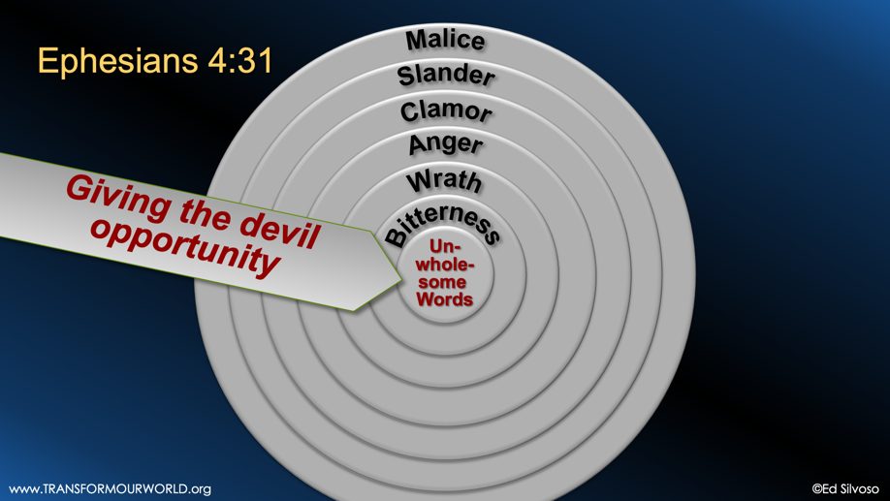
Ephesians 4:29

Let no unwholesome word come out of your mouth, but if there is any good word for edification according to the need of the moment, say that, so that it will give grace to those who hear.

2. Divisions that give him power to destroy our inner perimeter

SUMMARY

- The parallel between Ephesus and TOWHAWAII
- The requirement to be strong in the Lord AND in the power of His right
- The need to put on the FULL armor
- What fiery darts reveal: the devil is outside and those darts are only effective is they hit combustible material
- Anger sets the stage for divisions, which h in turn allows the devil to invade and destroy us from within

Reflection and Application

a) Have we given room to the devil through anger?
b) Has our unity been breached?
c) Is prayer the driver for everything we do?
d) Do we trust God fully

"Trust in the Lord with ALL your heart and lean NOT on your own understanding."
Personal Observations
- What TOWHAWAII already has already.
- Whoever controls the timing most likely determines the outcome.
- On the evil day, Jesus used silence or open ended answers as a weapon to set a process in motion.

  - John 14:30
I will not speak much more with you, for the ruler of the world is coming, and he has nothing in regard to Me

  - Matthew 27:12-14
When the leading priests and the older Jewish leaders accused Jesus, he said nothing. So Pilate said to Jesus, "You hear these people accusing you of all these things. Why don't you answer?" But Jesus said nothing to answer Pilate. Pilate was very surprised at this.

